EXPERIMENT – 8

Title
Smart Healthcare Monitoring System using google collab

Aim
To design and simulate a smart healthcare monitoring system that monitors patient vital parameters and detects abnormal conditions using Python in Google Colab.

Apparatus / Software Required
- Google Colab
- Python 3
- Pandas
- Matplotlib
- Random library
- IPython Display library

Objectives
To simulate the monitoring of multiple patients using respiratory rate, systolic blood pressure, diastolic blood pressure, blood glucose level, and pulse rate, identify abnormal patient conditions, classify patients as NORMAL or EMERGENCY, visualize the monitored parameters using graphs, and generate a final patient monitoring report in CSV format.

Theory
A Smart Healthcare Monitoring System continuously monitors important patient health parameters using sensors or simulated data. In this experiment, five parameters are considered:
- Respiratory Rate – Number of breaths per minute.
- Systolic Blood Pressure – Pressure in the arteries during heart contraction.
- Diastolic Blood Pressure – Pressure in the arteries when the heart relaxes.
- Blood Glucose – Amount of glucose present in the blood.
- Pulse Rate – Number of heartbeats per minute.
The system generates simulated readings for ten patients. Each reading is compared with predefined threshold values. If any parameter falls outside the specified range, the patient is classified as EMERGENCY. Otherwise, the patient is classified as NORMAL.
The system also displays the patient's readings graphically and stores all collected data in a CSV file for further analysis.

Monitoring Conditions
Parameter | Normal Range Used in Simulation
Respiratory Rate | 12 – 20 breaths/min
Systolic BP | 90 – 140 mmHg
Diastolic BP | 60 – 90 mmHg
Blood Glucose | 70 – 140 mg/dL
Pulse Rate | 60 – 100 BPM
Note: These ranges are used only as simulation thresholds for the experiment and are not intended for medical diagnosis.

Algorithm
- Start the program.
- Import the required Python libraries.
- Create a list containing ten patients.
- Create empty lists to store patient measurements and status.
- Select each patient one by one.
- Generate random values for:
  - Respiratory rate
  - Systolic blood pressure
  - Diastolic blood pressure
  - Blood glucose
  - Pulse rate
- Compare each parameter with its defined simulation threshold.
- If any parameter is outside the normal range, classify the patient as EMERGENCY.
- Otherwise, classify the patient as NORMAL.
- Display the patient's vital parameters and status.
- Generate graphs for all monitored parameters.
- Repeat the process for all ten patients.
- Create a final DataFrame containing all patient records.
- Count the number of NORMAL and EMERGENCY patients.
- Save the final report as a CSV file.
- Display the completion message.
- Stop the program.

Procedure
- Open Google Colab.
- Create a new Python notebook.
- Import random, time, pandas, matplotlib, and clear_output.
- Define the list of ten patients.
- Initialize lists for storing patient readings.
- Generate simulated healthcare data for each patient.
- Check the readings against the predefined threshold values.
- Display the patient's current readings and status.
- Display graphical representations of the vital parameters.
- Continue the simulation for all ten patients.
- Generate the final patient report using Pandas.
- Calculate the number of NORMAL and EMERGENCY patients.
- Save the report as Smart_Healthcare_Report.csv.
- Observe the final output and graphs.

Sample Patient Data
Patient | Respiratory Rate | Systolic BP | Diastolic BP | Glucose | Pulse | Status
Patient 1 | 16 | 120 | 80 | 100 | 75 | NORMAL
Patient 2 | 10 | 125 | 82 | 110 | 80 | EMERGENCY
Patient 3 | 18 | 135 | 85 | 120 | 78 | NORMAL
Patient 4 | 15 | 145 | 88 | 105 | 82 | EMERGENCY
Patient 5 | 14 | 130 | 99 | 85 | 80 | EMERGENCY
The actual values will change because the program generates random readings.

Sample Output
=================================================================
SMART HEALTHCARE MONITORING SYSTEM
=================================================================

Patient : Patient 5
Respiratory Rate : 10 breaths/min
Systolic BP : 93 mmHg
Diastolic BP : 99 mmHg
Blood Glucose : 85 mg/dL
Pulse Rate : 80 BPM
Status : EMERGENCY
In this example, the patient is classified as EMERGENCY because the respiratory rate and diastolic blood pressure are outside the simulation's defined normal ranges.
Phyton code:
# ===========================================
# Case Study : Smart Healthcare Monitoring System
# Google Colab Simulation
# ===========================================

import random
import time
import pandas as pd
import matplotlib.pyplot as plt
from IPython.display import clear_output

# -------------------------
# Patient Names
# -------------------------

patients = [
"Patient 1", "Patient 2", "Patient 3", "Patient 4", "Patient 5",
"Patient 6", "Patient 7", "Patient 8", "Patient 9", "Patient 10"
]

respiratory_data = []
systolic_data = []
diastolic_data = []
glucose_data = []
pulse_data = []
status_data = []

# -------------------------
# Simulation
# -------------------------

for patient in patients:

respiratory = random.randint(10, 25)
systolic = random.randint(80, 160)
diastolic = random.randint(50, 100)
glucose = random.randint(60, 180)
pulse = random.randint(50, 125)

respiratory_data.append(respiratory)
systolic_data.append(systolic)
diastolic_data.append(diastolic)
glucose_data.append(glucose)
pulse_data.append(pulse)

# -------------------------
# Emergency Detection
# -------------------------

if (
respiratory < 12 or respiratory > 20 or
systolic < 90 or systolic > 140 or
diastolic < 60 or diastolic > 90 or
glucose < 70 or glucose > 140 or
pulse < 60 or pulse > 100
):
status = "EMERGENCY"
color = "red"
else:
status = "NORMAL"
color = "green"

status_data.append(status)

# -------------------------
# Live Display
# -------------------------

clear_output(wait=True)

print("=" * 65)
print(" SMART HEALTHCARE MONITORING SYSTEM")
print("=" * 65)

print("\nPatient :", patient)
print("Respiratory Rate :", respiratory, "breaths/min")
print("Systolic BP :", systolic, "mmHg")
print("Diastolic BP :", diastolic, "mmHg")
print("Blood Glucose :", glucose, "mg/dL")
print("Pulse Rate :", pulse, "BPM")
print("Status :", status)

# -------------------------
# Graphs
# -------------------------

plt.figure(figsize=(15, 8))

# Respiratory Rate
plt.subplot(2, 3, 1)
plt.bar(
["Respiratory"],
[respiratory]
)
plt.ylim(5, 30)
plt.title("Respiratory Rate")
plt.ylabel("Breaths/min")

# Systolic BP
plt.subplot(2, 3, 2)
plt.bar(
["Systolic"],
[systolic]
)
plt.ylim(70, 170)
plt.title("Systolic Blood Pressure")
plt.ylabel("mmHg")

# Diastolic BP
plt.subplot(2, 3, 3)
plt.bar(
["Diastolic"],
[diastolic]
)
plt.ylim(40, 110)
plt.title("Diastolic Blood Pressure")
plt.ylabel("mmHg")

# Blood Glucose
plt.subplot(2, 3, 4)
plt.bar(
["Glucose"],
[glucose]
)
plt.ylim(40, 200)
plt.title("Blood Glucose")
plt.ylabel("mg/dL")

# Pulse Rate
plt.subplot(2, 3, 5)
plt.bar(
["Pulse"],
[pulse]
)
plt.ylim(40, 140)
plt.title("Pulse Rate")
plt.ylabel("BPM")

# Status
plt.subplot(2, 3, 6)
plt.bar(
["Status"],
[1],
color=color
)
plt.ylim(0, 1.2)
plt.title("Patient Status")
plt.text(
0,
0.5,
status,
ha="center",
fontsize=12
)
plt.xticks([])

plt.tight_layout()
plt.show()

time.sleep(2)

# -------------------------
# Final Report
# -------------------------

report = pd.DataFrame({

"Patient": patients,
"Respiratory Rate": respiratory_data,
"Systolic BP": systolic_data,
"Diastolic BP": diastolic_data,
"Blood Glucose": glucose_data,
"Pulse Rate": pulse_data,
"Status": status_data

})

print("\n" + "=" * 65)
print(" FINAL REPORT")
print("=" * 65)

print(report)

# -------------------------
# Summary
# -------------------------

normal = len(
report[report["Status"] == "NORMAL"]
)

emergency = len(
report[report["Status"] == "EMERGENCY"]
)

print("\nNORMAL Patients :", normal)
print("EMERGENCY Patients :", emergency)

# -------------------------
# Save CSV
# -------------------------

report.to_csv(
"Smart_Healthcare_Report.csv",
index=False
)

print("\nCSV File Saved Successfully")
print("File Name: Smart_Healthcare_Report.csv")
print("\nHealthcare Monitoring Completed Successfully!")
Output:
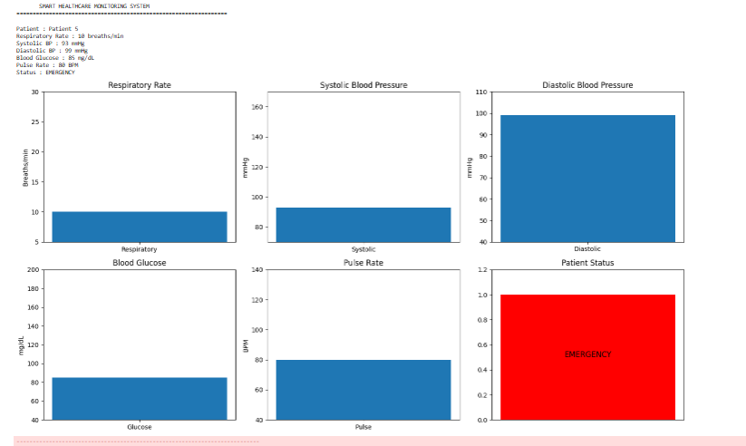

Result
The Smart Healthcare Monitoring System was successfully simulated using Python in Google Colab. The system monitored respiratory rate, blood pressure, blood glucose, and pulse rate, identified abnormal readings, classified patients as NORMAL or EMERGENCY, displayed the parameters using graphs, and generated a final healthcare monitoring report in CSV format.

